**Date : PASSPORT AUOMATION SYSTEM**

**Ex No:**

**AIM:**

To Design, Implement and Test the Passport Automation described in the given problem statement

**PROBLEM STATEMENT:**

Passport Automation System is used in the effective dispatch of passport to all the applicants. This system adopts a comprehensive approach to minimize the work load of both the applicant and the persons who are involved in verification process. The main aim of the system to create a online registration form that includes details about the applicant like name, permanent address and etc along with the proof are being uploaded in it for verification. The amount must be paid to government after all the personal details being uploaded.

After testing the genuineness of the documents that are being uploaded by the applicant in the passport automation system and the information is sent to regional administrator’s office. If all the documents that have been provided are genuine an appointment date is sent as a message to the applicant for further verification of the documents and also a person is assigned to check for personal verification. While verification if any forfeiting is identified, the applicant is liable for penalty and further action will be taken.

After the passport being issued its validity is for 10 years and for renewing process a request must be give to the regional administrator’s office and a new passport with validity for the next 5 years will be provided after the above process are done for verification.

**USE CASE DIAGRAM**



**CLASS DIAGRAM**



**SEQUENCE DIAGRAM:**

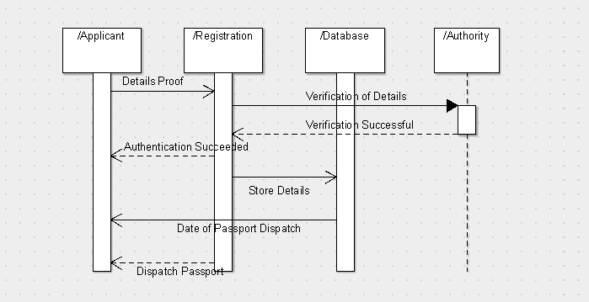

**ACTIVITY DIAGRAM**

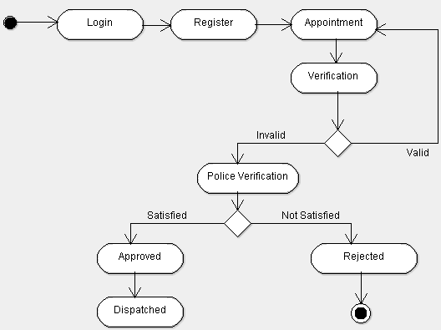

**STATE CHART DIAGRAM**



**COMPONENT DIAGRAM**



**DEPLOYMENT DIAGRAM**

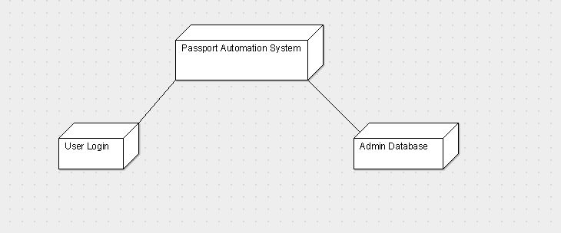

**IMLEMENTATION AND TESTING: PASSPORT AUTOMATION SYSTEM**

**Person.java**

package passport;

import passport.Police;

import java.util.*;

class Person

{

public static void main(String args[])

{ Scanner sc= new Scanner(System.in);

int e ;

do

{

System.out.println("******passort automation system******");

System.out.println(" 1.Apply passport\n 2.Police verification \n 3.passport generation");

int n = sc.nextInt();

switch(n)

{

case 1: Passport p = new Passport();

System.out.println(" wlcome passport application !");

p.apply();

break;

case 2: Police g = new Police();

System.out.println("passport verification");

g.verify( );

break;

case 3 : Passport p1 = new Passport();

p1.generate();

break;

default :

System.out.println("kindly do the previous operations");

}

System.out.println("press 1 for home page");

e = sc.nextInt();

}while(e ==1);

}

}

**Passport.java**

package passport;

import static java.lang.System.exit;

import passport.Police;

import java.util.Random;

import java.util.*;

class Passport {

public static String name ,gender,mailId,x ;

public static String id,DOB;

public static long phone_no;

public static int c;

Scanner s1 = new Scanner(System.in);

public void apply()

{

System.out.println( " Enter the your name " );

name = s1.next();

System.out.println( " Enter the your gender " );

gender = s1.next();

System.out.println( " Enter the your birth date (dd/mm/yyyy) " );

DOB = s1.next();

System.out.println( " Enter the your Mail Id " );

mailId = s1.next();

System.out.println("Eneter your Aadhar Id (12 digit) number");

id = s1.next();

int i=id.length();

while(i!=12)

{

System.out.println("Renter the id .");

id = s1.next();

i= id.length();

}

System.out.println("Eneter your mobile number");

phone_no = s1.nextLong();

System.out.println("your application id is been generating");

Random r = new Random();

c = (r.nextInt( 0x171)+ 1000);

System.out.println("application id is "+c);

System.out.println("\n \n Press y to proceed next section ...\n");

String f = s1.next();

if( "y".equals(f))

{

Police g = new Police();

g.verify( );

}

x = ("A54"+Integer.toString(r.nextInt()));

}

public void generate(){

System.out.println("************passport generation************");

System.out.println("****PASSPORT *****");

System.out.println("** GOV OF INDIA **");

System.out.println("PASSPORT NO :"+x);

System.out.println("NAME :"+name);

System.out.println("DOB :" +DOB);

System.out.println("GENDER :" +gender);

System.out.println("MAILID :"+mailId);

System.out.println("PH NO :"+phone_no);

exit(0);

}

}

**Police.java**

package passport;

import java.util.Scanner;

class Police {

public void verify()

{ Scanner s2 = new Scanner(System.in);

System.out.println("\n Police verificating your passport application ...");

System.out.println("Enter your name");

String sname=s2.next();

System.out.println("\n Enter your application id to complete verification");

int i = s2.nextInt();

if((i!=Passport.c)&&(sname.equals(Passport.name)))

{

System.out.println("unauthenticate user");

}

else

{

System.out.println("verified sucessfully");

System.out.println("press y to proceed next section ...");

String f = s2.next();

if( "y".equals(f))

{

Passport p1 =new Passport();

p1.generate( );

}

}

}

}

**OUTPUT**

run:

******passort automation system******

1.Apply passport

2.Police verification

3.passport generation

1

welcome passport application !

Enter the your name

Manish

Enter the your gender

Male

Enter the your birth date (dd/mm/yyyy)

12/09/1999

Enter the your Mail Id

manishraghu@yahoo.com

Enter your Aadhar Id (12 digit) number

740550346166

Enter your mobile number

7358682980

your application id is been generating

application id is 1169

Press y to proceed next section ...

y

Police verifying your passport application ...

Enter your name

Manish

Enter your application id to complete verification

1169

verification successful

press y to proceed next section ...

n

press 1 for home page

1

******passort automation system******

1.Apply passport

2.Police verification

3.passport generation

3

************passport generation************

****PASSPORT *****

** GOV OF INDIA **

PASSPORT NO :A54-1300338742

NAME : Manish

DOB : 12/09/1999

GENDER :Male

MAILID :manishmoni1209@gmail.com

PH NO :358682980

BUILD SUCCESSFUL (total time: 2 minutes 3 seconds)

**TEST REPORT 1**

**Product :** Passport Automation System

**Use Case :** Applying Passport

|  |  |  |  |  |
| --- | --- | --- | --- | --- |
| **Test Case ID** | **Test Case / Action To Perform** | **Expected Result** | **Actual Result** | **Pass/Fail** |
| 1. | To apply for passport | Press 1 for passport application | Displays details on what to be uploaded. | Pass |
| 2. | After Entering ‘1’ for Passport Application | Enter the details | After entering you can proceed to next section | Pass |
| 3. | Press ‘Y’ to move onto next section | You can check whether the  Passport is verified or not. | Details about your passport verification. | Pass |
| 4. | Press ‘1’ to move to home page | To go to home page | Displays home page | Pass |
| 5  5. | Press ‘3’ for Passport Generation | Passport details | Your passport has been generated with your passport id. | Pass |